Welcome Windjammer Families,

Please help us with SAFE and smooth drop off / pick up. We are limited in space in terms of parking and loops. Please see the below information and the attached map.
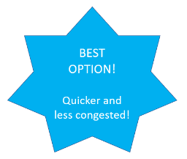
- BEAT THE TRAFFIC and let our crossing guards work their magic… If you park about a half block / block away at one of three less congested spots, your child will be safely guided to and from school by any of our five crossing guards. (Thank you South Weber City) This will save you time.
  - Along the South Side of Lester Drive WEST of 1160 East
  - Long strip of parking along the front of Central Park on Lester Drive
  - Church Parking Lot on 1375 East
- The K-2 Loop off of 1160 East is for buses only.
- If using 3-6 loop, drop off / pick up should be in right lane only. We don’t want kids crossing a lane of cars.
- If using 3-6 loop, right lane is a “right turn only” out of our loop.
- Watch for and follow crossing guard directions.
- Do not park on 1160 East. (West of the K-2 Center) Our friendly neighbors on this street need to be able to get in and out of their driveways.
- If you are headed to the East end of town after school, you can avoid the crosswalk on South Weber Drive by heading East on Lester Drive and then North on 1375 East (by the fire station) rather than using 1250 East.
- Please save phone calls, texts, and email messages for another time.
- Take it slow and watch for pedestrians, other cars, buses.
- Thank you for being patient, attentive, and courteous.

Even with as many students (almost 800), cars, and drivers as we accommodate during pick up and drop off, our loops are all but empty within 10 minutes of the bell ringing. With that said, it can always run more smoothly, and we appreciate feedback and suggestions.
Thank you for all you do to support the Windjammers!
Brooke Paras and Catherine Kohl
Principal and Assistant Principal

